

INTERNSHIP REPORT

GLOBAL TECH INTERN

**REPORT**

Name: Manoj kumar S

Domain name: Artificial Intelligence and Machine Learning

Duration: 1 Month

Task Completed : 2

# ABSTRACT

During my Artificial Intelligence and Machine learning internship, I had the opportunity to work on various Machine Learning projects. I gained practical experience in Artificial Intelligence technologies such Math, Statistics as well as in using popular Machine learning libraries such as Data Preprocessing . Throughout my internship, Artificial intelligence is important because it combines tools, methods, and technology to generate meaning from data. Modern organizations are drowned with data; there is a proliferation of devices that can automatically collect and store information. Additionally, I learned valuable soft skills such as communication, teamwork, and time management. Overall, My Artificial Intelligence and Machine Learning internship provided me with a comprehensive understanding of the Data Analysis process, and has given me the confidence to pursue a career in this field.

I am thankful to Global Tech Training Associates for teaching and assisting me in making the training successful.

## About Training:

The Artificial intelligence and Machine Learning Training by Internshala is a 4-week online training program in which Global-Tech aim to provide you with a comprehensive introduction to data science. In this training program, you will learn the basics of python, statistics, predictive modeling, and Machine Learning. This training program has video tutorials and is packed with assignments, assessments tests, quizzes, and practice exercises for you to get a hands-on learning experience. At the end of this training program, you will have a solid understanding of data science and will be able to build an end-to-end predictive model. For doubt clearing, you can post your queries on the forum and get answers within 24 hours.

The work in this report is an outcome of continuous work over a period and drew intellectual support from Global-Tech and other sources. I would like to articulate our profound gratitude and indebtedness to Global-Tech helped using completion of the training. I am thankful to Global-Tech Training Associates for teaching and assisting me in making the training successful.

## Artificial intelligence and Machine learning Overview:

Machine Learning (ML): Machine learning is a field of computer science that uses algorithms to process large amounts of data and learn from it. Unlike traditional rules-based programming, ML models10 learn from input data to make predictions or identify meaningful patterns without being explicitly programmed to do so. There are different types of ML models, depending on their intended function and structure:

Supervised Machine Learning: In supervised ML, the model is trained with labeled input data that correlates to a specified output. For example, a dataset of animal photos (input data) can be labeled as “cats” or “not cats” (output data). The model is continuously refined to provide more accurate output as additional training data becomes available. After the model has learned from the patterns in the training data, it can then analyze additional data to produce the desired output. Results of supervised ML models are typically reviewed by humans for accuracy and fed back into the model for further refinement. Supervised ML is successful when the model can consistently produce accurate predictions when provided with new datasets. For example, the ML model learns to recognize if a new picture is a cat or not.

Unsupervised Machine Learning: In unsupervised ML, the input data is not labeled nor is the output specified. Instead, the models are fed large amounts of raw data and the algorithms are designed to identify any underlying meaningful patterns. The algorithms may cluster similar data but do so without any preconceived notion of the output. For example, a time series of trade events can be inputted into an unsupervised model, with the model identifying groups of similar trades as well as outliers. Results of unsupervised machine learning models are then interpreted by humans to determine if they are meaningful and relevant.

Reinforcement Learning: In reinforcement learning, the model learns dynamically to achieve the desired output through trial and error. If the model algorithm performs correctly and achieves the intended output, it is rewarded. Conversely, if it does not produce the desired output, it is penalized. Accordingly, the model learns over time to perform in a way that maximizes the net reward. For example, in the securities industry, reinforcement learning models are being explored for options pricing and hedging.11

## Applications of Machine learning :

Machine learning is one of the most exciting technologies that one would have ever come across. As is evident from the name, it gives the computer that which makes it more similar to humans: The ability to learn. Machine learning is actively being used today, perhaps in many more places than one would expect.

Today, companies are using Machine Learning to improve business decisions, increase productivity, detect disease, forecast weather, and do many more things. With the exponential growth of technology, we not only need better tools to understand the data we currently have, but we also need to prepare ourselves for the data we will have. To achieve this goal we need to build intelligent machines. We can write a program to do simple things. But most of the time, Hardwiring Intelligence in it is difficult. The best way to do it is to have some way for machines to learn things themselves. A mechanism for learning – if a machine can learn from input then it does the hard work for us. This is where Machine Learning comes into action. Some of the most common examples are:

* Image Recognition
* Speech Recognition
* Recommender Systems
* Fraud Detection
* Self-Driving Cars
* Medical Diagnosis
* Stock Market Trading
* Virtual Try On

**Introduction**

Machine learning is programming computers to optimize a performance criterion using example data or experience. We have a model defined up to some parameters, and learning is the execution of a computer program to optimize the parameters of the model using the training data or experience. The model may be predictive to make predictions in the future, or descriptive to gain knowledge from data.

The field of study known as machine learning is concerned with the question of how to construct computer programs that automatically improve with experience.

Machine learning is a subfield of artificial intelligence that involves the development of algorithms and statistical models that enable computers to improve their performance in tasks through experience. These algorithms and models are designed to learn from data and make predictions or decisions without explicit instructions. There are several types of machine learning, including supervised learning, unsupervised learning, and reinforcement learning. Supervised learning involves training a model on labeled data, while unsupervised learning involves training a model on unlabeled data. Reinforcement learning involves training a model through trial and error. Machine learning is used in a wide variety of applications, including image and speech recognition, natural language processing, and recommender systems.

**Task no-1**

# Implementing The linear Regression Algorithm:

Implement a linear regression algorithm using Python and scikit-learn, and train it on a dataset to predict a continuous target variable. Linear Regression is an ML algorithm used for supervised learning. Linear regression performs the task to predict a dependent variable(target) based on the given independent variable(s). So, this regression technique finds out a linear relationship between a dependent variable and the other given independent

**Solution**

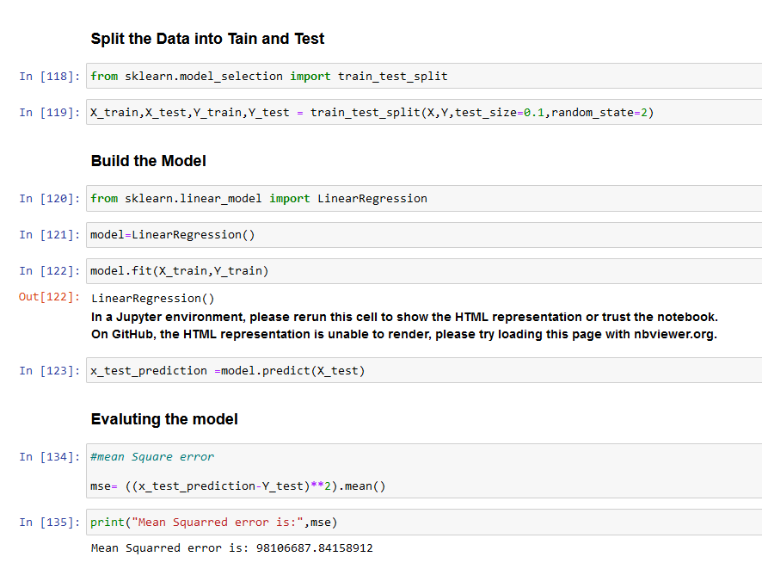

**Task no-2**

Develop a decision tree algorithm using Python and scikit-learn, and train it on a dataset to classify categorical or binary target variables.

**Solution**

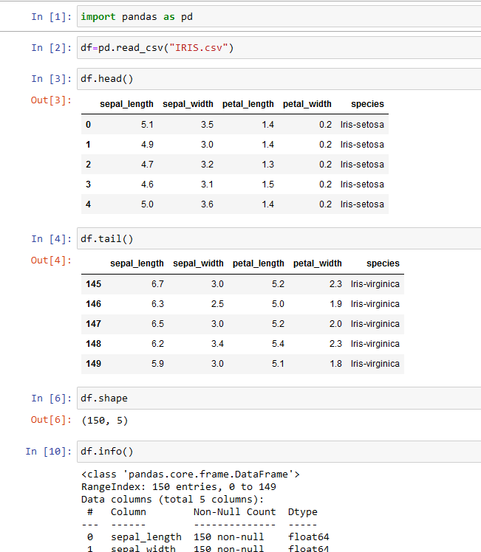

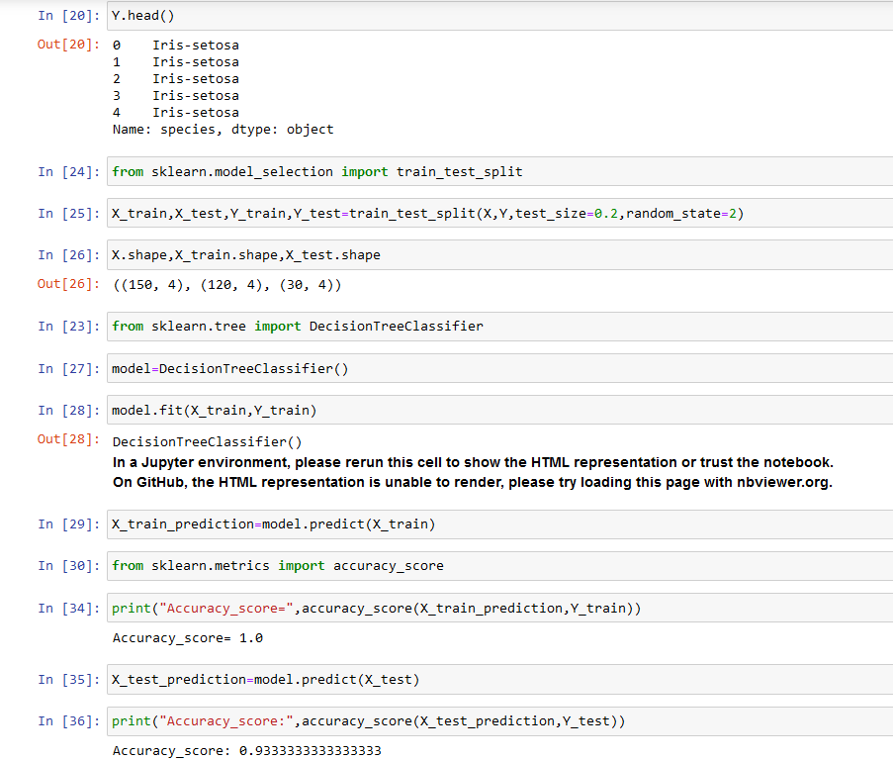

**Conclusion:**

When I first started my Artificial Intelligence and Machine Learning internship, I didn’t really know what I was getting myself into. I had only worked on personal projects up until that point, and I wasn’t at all familiar with what the working environment would be like, the data I would have to work with, and the tools I’d have to use. I was told that strong Python was a requirement for the position and spent a couple of weeks brushing up on my programming skills.

Overall, my one-month internship in Artificial and Machine learning was a great learning experience for me. I gained hands-on experience with Python and Machine Learning along with Python Libraries Such Matplotlib, Scikit-learn, Pandas, NumPy. The Work Experience I encountered during the internship allowed me to developed data science skills the overall experience positive & everything I learned would be useful in my feature Career in this field